Creating a Virtual Network :

Virtual Network created :

Selecting the network as VNet1 for Virtual Machine:

Creating my Virtual Machine in the Virtual Network:

Creating a Load Balancer :

To get a HTML Page, we are installing the Nginx in one single CLI Command :

Letting my Web Server serve a Web Page like :

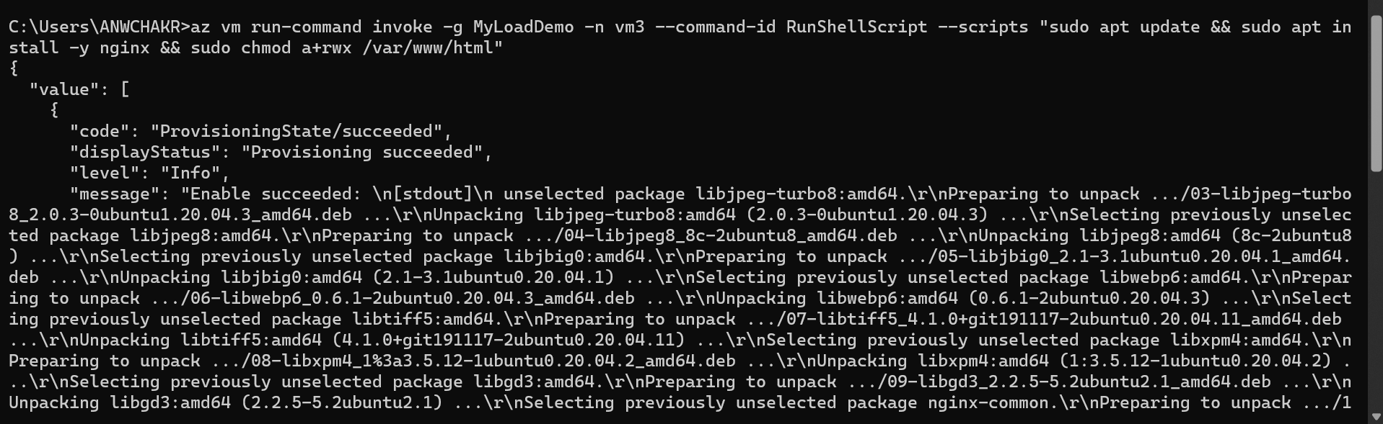

The virtual machine mymachine running the webpage:

Webser1 and Webserver2 are running :

__________________________________________________________________________________

**CREATING GLOBAL LOAD BALANCER**

Creating another Virtual Machine vmineurope under a new load balancer LoadinEurope:

Creating a Global Virtual Machine which will connect all the virtual machine:

This means, vm3 and mymachine virtual machines are created under a Load Balancer MyLoaad

We create another virtual machine vmineurope under Load Balancer LoadinEurope

When one virtual machine , like vm3 stops working in one region, another vm like ‘mymachine’ and ‘vmineurope’ will start working.

In case both the vm’s in one region like vm3 and mymachine stops working, then vmineurope under LoadinEurope which is in another region, like EastUS start working.

We are sending Port 80 as the default traffic :

